RANA JAHANZAIB DAEWOO

SERVICES

**Ref No: 27/RJDS**

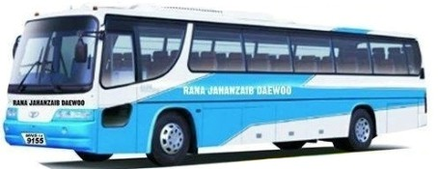

**Date:<To>**

**TO WHOM IT MAY CON****CERN**

It is certified that Mr. <Name> S/O <fname> has worked with us as <Designation> in Rana Jahanzaib Daewoo Services, Multan from <From> to <To>.

During this period, his services were found satisfactory. We wish him every success in his future life.

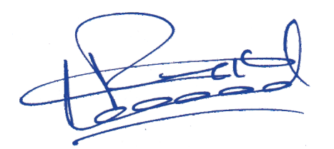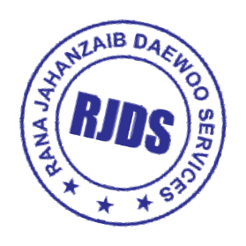

**General Manager**

Lari Adda, Lahore Cell #. +92-300‑9743348